**ASSIGNMENT 1**

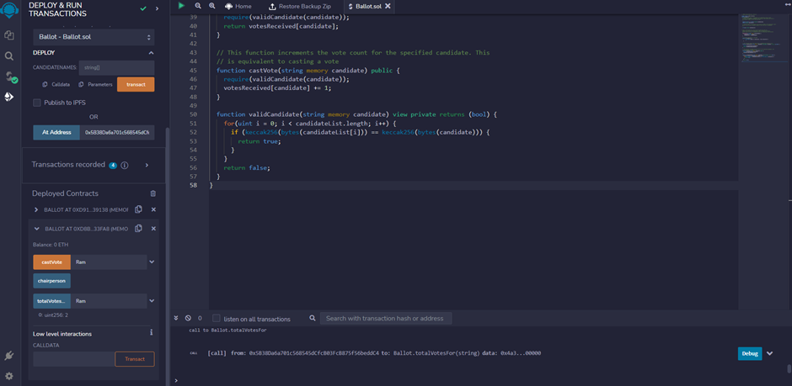

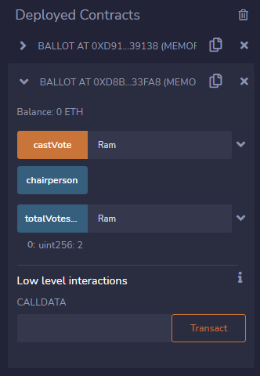

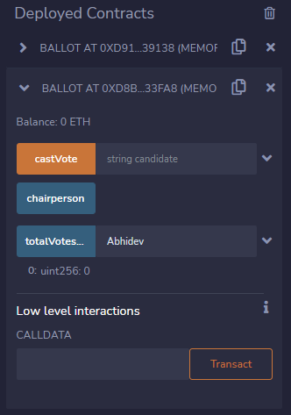

* Entered Candidate list as “Abhidev”,”Ram”,”Yadu”
* Deployed the transaction with address of Remix VM London account
* Casted the vote for “Ram” twice. Ram has two votes
* The Candidate “Abhidev” has zero votes